Patient Newsletter January/February 2024
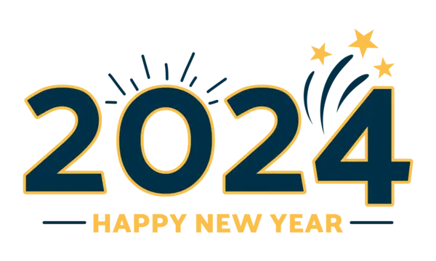  We would like to wish all our Patients a happy new year for 2024.  This year we will be making changes to the way we operate in the practice; this will hopefully help patients have an easier experience in making/arranging appointments. Please see below for further information.  NEW eConsult System  We have recently reviewed our current appointment system with an aim to improve patient access to our practice. From the 12th of February 2024, we are changing our appointment system. We believe this will ensure that you, the patient, are supported by the right medical professional in the right way, at the right time.  Our current online system "eConsult" is changing and will now become the main way to ask us for medical advice and for all administrative help, such as test results or sick note extensions. Please use eConsult as your first choice when contacting us if you can, as this will be the fastest and most effective way for you and the practice.  *WE WILL NO LONGER BE ACCEPTING BOOKING APPOINTMENTS AT THE FRONT DESK ON A MORNING*  PLEASE SEE ATTACHED FURTHER INFORMATION.  FLU VACCINATIONS  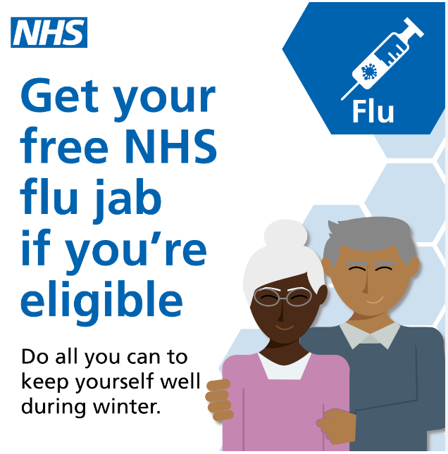  If you are eligible and still not had your flu vaccination, please ask our reception team.  Children between 2-3 are also eligible for a nasal flu vaccine. Please ask our receptionist if you would like your child to receive this.  PLEASE NOTE: Limited vaccines available.  NHS Health Checks  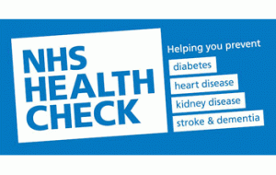  All patients eligible will receive a text message inviting them to book in for a free NHS Health Check. This is an extremely useful check-up as it can tell you whether you are at high risk of getting certain health problems, such as, Heart Disease, Diabetes, Kidney Disease or Stroke.  PLEASE NOTE: Eligible to patients aged 40-74 years, who have NOT had a health check in over 5 years. | Patient Education Sessions  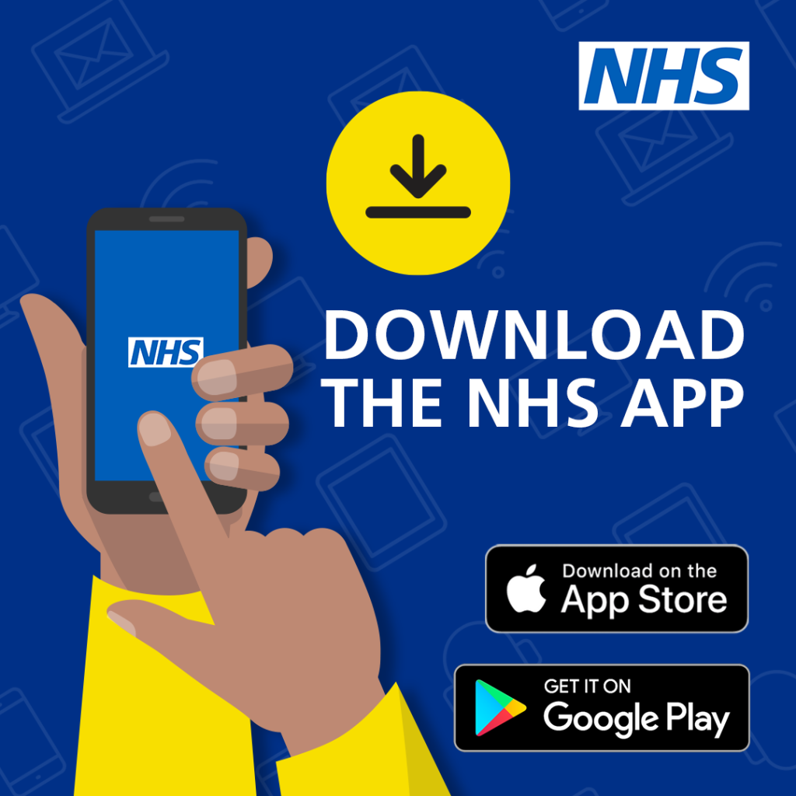  We will be holding an educational session for patients on the 13th of February at 6pm on the NHS App. At this session there will be staff members on hand to show you how to download to your smartphone and how the NHS app works and its features.  PLEASE NOTE: you will need a smartphone to be able to access the NHS app, and you will need to bring your ID with you for this to work.  Self-Referral Pathway  Patients can now self-refer to the following departments: Podiatry, Audiology, Physiotherapy, and Musculoskeletal (MSK).  PLEASE SEE ATTACHED MORE INFORMATION.  New Doctors  We are happy to announce that we have 3 new GP's joining our team in February and March this year.  Further details will be shared nearer the time.  Patient Feedback from December 2023  Thank you to all our patients who have completed our Friends & Family Test for December 2023. Below are the results of how our patients rated their experience in December.  Very Good: 152  Good: 37  Neither Good Nor Poor: 9  Poor: 4  Very Poor: 9  Don't Know: 1  "Very understanding"  "Nurse was lovely and very attentive"  "Felt very comfortable"  "The GP attending to me thorough, caring and with excellent bedside manners."  "Very prompt and efficient service"  "Helpful friendly staff"  "The nurse was absolutely gorgeous!!!!!!!! Amazing bedside manner - thank you so much"  "All staff are excellent and very helpful"  "Nervous about doctors/ hospitals etc but the staff always make me feel more relaxed"  Don't forget to visit our Facebook page as this is updated regularly with current campaigns and other useful information. We have a link to this on our website www.acklammedicalcentre.co.uk  or search for us at  www.facebook.com/AcklamMedicalCentre

